How to copy azure data factory work from one data factory to other

1. Go to manage ->ARM template

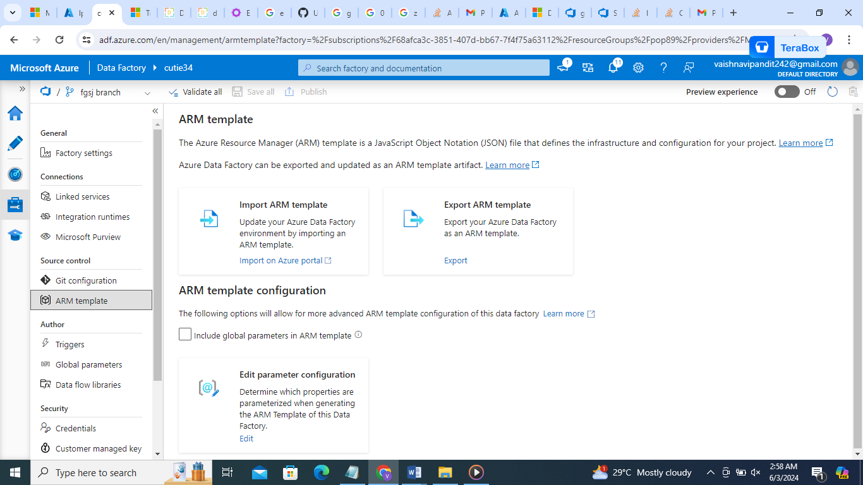

1. Go to export arm file will be downloaded extract it
2. Now go to second data factory import this there in arm templete

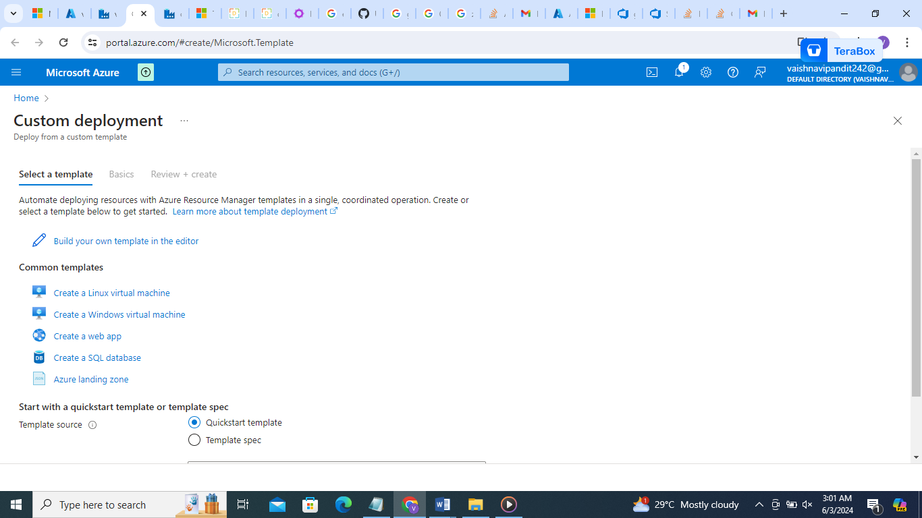

1. Click on build your own

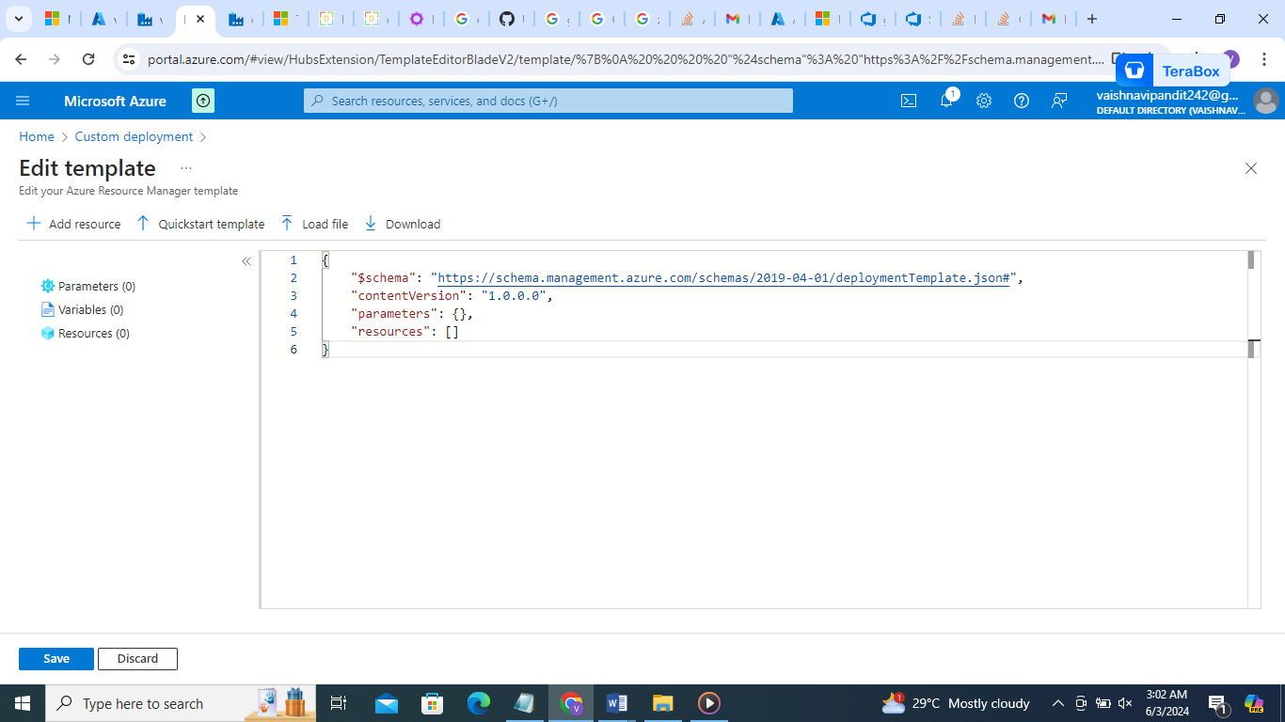

1. Go to load file

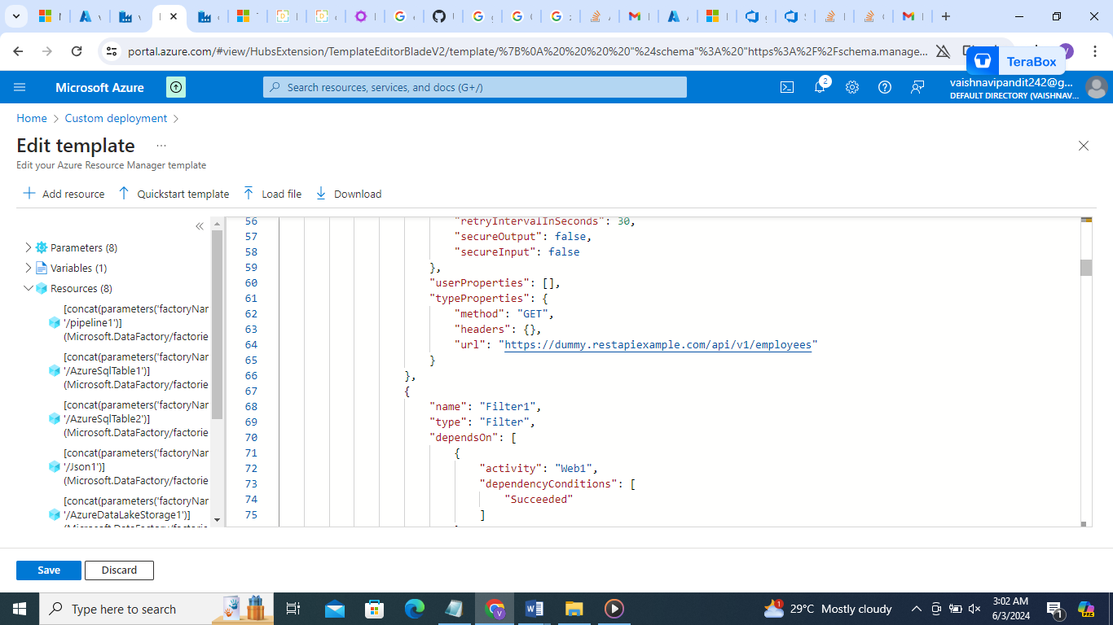

1. Save

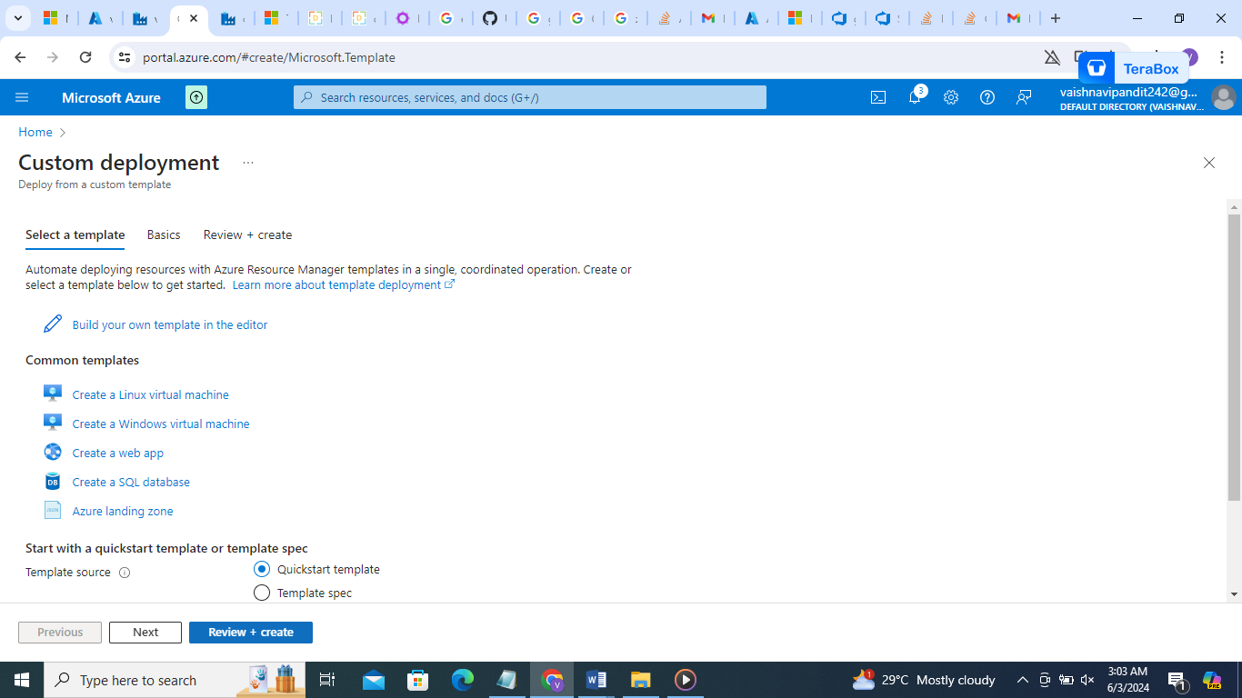

1. Create
2. 